PSSI Science Project Reporting Template

️ | The PSSI Implementation Team is compiling a technical report to demonstrate the important research and advancements made by the Science Branch through the PSSI funding. The technical report will include a 3-4 page summary (including graphics and figures) for each project to show their key results and findings. Please fill in the following fields and sections for your project to be included in the report. Feel free to include and draw from any reports or presentations previously created through your research.  A plain language science bulletin will also be created to follow up on last year’s “DFO Pacific Region Science Bulletin, 2024. New research and monitoring for Pacific salmon and their ecosystems.” While the first bulletin introduced project backgrounds, methods, and timelines, this new bulletin will highlight the projects’ results, key findings, and conclusions with links to reports and data available. The bulletin will include a 1-2 page summary for each project gleaned from the content entered below.  ️ Completed forms are due January 26, 2026.  *Please include or send separately any graphics or pictures (with photo credits) that will help promote the projects.

PART 1: PROJECT METADATA

General Project Information
Project ID (number) | Project Title
2404 | Improving baseline knowledge of environmental conditions in Vancouver Islands fjords through observations and modelling, with a focus on hypoxia dynamics, climate change, and the potential implications for Pacific salmon
Project Leads | Collaborations and External Partners
Laura Bianucci | Ahousaht First Nation, Hesquiaht First Nation, Tla-o-qui-aht First Nation, Nuu-cha-nulth Tribal Council, Nature Trust of BC, Maaqutusiis Hahoulthee Stewardship Society
Location (if applicable)
Clayoquot sound, WCVI

Geographic and Stock Information
Salmon species (if applicable) | Waterbodies (if applicable)
Click or tap here to enter text. | Clayoquot Sound
Life history phases (if applicable) | Region
Click or tap here to enter text. | WCVI
Stock (if applicable) | Population (if applicable)
Click or tap here to enter text. | Click or tap here to enter text.
Conservation Unit (if applicable)
Click or tap here to enter text.

🧰 PART 2: PROJECT METRICS

Project Outputs
Include any anticipated outputs denoted as (in progress). Please include links to any outputs available online so they can be referenced in the report.
List scientific publications and technical reports (with links)
Rosen S, Bianucci L, Jackson JM, Hare A, Greengrove C, Monks R, Bartlett M and Dick J (2022). Seasonal near-surface hypoxia in a temperate fjord in Clayoquot Sound, British Columbia. Front. Mar. Sci. 9:1000041. doi: 10.3389/fmars.2022.1000041, https://www.frontiersin.org/journals/marine-science/articles/10.3389/fmars.2022.1000041/full

Foreman, M. G. G., Chandler, P. C., Bianucci, L., Wan, D., Krassovski, M. V., Thupaki, P., … Lin, Y. (2024). A Circulation Model for Inlets Along the Central West Coast of Vancouver Island. Atmosphere-Ocean, 62(1), 58–89. https://doi.org/10.1080/07055900.2023.2262957

Bianucci L, Foreman M, Callendar W, Izett J, Greengrove C, et al (in progress). Mechanisms Generating a Subsurface Temperature Minimum in a Silled, Temperate Fjord.

Geng M, Bianucci L, et al (in progress). Assessing climate change in Clayoquot Sound, BC, and potential impacts to Pacific Salmon.

List datasets generated (with links)
Observational datasets related to this project (CTD profiles, mooring and weather station data) can be found in www.waterproperties.ca using “Scientist” = “Bianucci” or “Cooper” in the search engine.

Model outputs are currently available per-request. Given their size (hundreds of gigabytes) and complexity, these outputs are better shared through communications with Dr. Bianucci
Describe dataset locations and data management systems
Observational datasets are located at the Institute of Ocean Sciences (IOS) server and shared publicly via www.waterproperties.ca. The Data Team at the Ocean Sciences Division at IOS are in charge of data management.
List code, programs, or other software created (with links)
Click or tap here to enter text.
List communication or social media products
DFO’s Fieldnotes publications have communicated summaries of the fieldwork activities in Clayoquot Sound related with this PSSI project since 2022 (CTD monitoring, weather stations, mooring deployment and servicing). In particular, Fieldnotes 2025-26 highlighted part of the CTD monitoring program in Clayoquot Sound in a Collaboration Visualizer poster.
List and describe field work completed
Weather station network: 1 or 2 trips per year since 2022 to the different sounds in the west coast of Vancouver Island (WCVI) to install and/or service weather stations.
DFO-led CTD sampling: profiles of temperature, salinity and oxygen taken in each sound during the trips to service weather stations. The instrument is called CTD after “Conductivity, Temperature, Depth”.
Indigenous-led CTD monitoring: since 2024, CTD profiles sampled by indigenous groups in Clayoquot Sound. This PSSI project funded three local Nations to perform ~monthly sampling. Sampling trips were organized and led by the Central Region Biologist at Uu-a-thluk Fisheries (Nuu-chah-nulth Tribal Council). A second collaboration with Maaqutusiis Hahoulthee Stewardship Society also started in 2024 and contributes CTD profiles in Ahousaht territory (no funds provided from DFO).
Mooring deployment and servicing: two moorings were deployed in 2022 and serviced annually since then. These two moorings measure the currents at all depths in each location, and they also have sensors to measure temperature, salinity and oxygen at some vertical levels. These data give us continuous time series.

These datasets helped create forcing fields for the ocean model of the WCVI and also provided data for the evaluation of the model’s performance.

List and describe samples collected/analyzed (number of samples)
Weather stations: 72 records under “Scientist” = “Bianucci” in all of the WCVI
DFO-led CTD profiles: 432 records in the region of the WCVI model, found under “Scientist” = “Cooper” since June 2022. Note: more CTD records are available through other projects.
Indigenous-led CTD profiles: 150 records under “Scientist” = “Bianucci” in Clayoquot Sound. From these records, 124 belong to the “Project” = “Clayoquot Sound CTD Monitoring Program” and were collected by Uu-a-thluk Fisheries along with Ahousaht, Hesquiaht, and/or Tla-o-qui-aht First Nations. The other 26 records belong to “Project” = “Ahousaht Territory CTD Monitoring Program”, with samples collected by the Maaqutusiis Hahoulthee Stewardship Society (MHSS) team.
Moorings: 12 CTD records and 6 ADCP (currents) records for both moorings, called Clay1 and Clay2. Best way to find these records is to search for filenames that start with “clay” in waterproperties.ca

Note: 2025 data not fully processed nor available yet.

List and describe large capital assets or equipment acquired
No large capital assets. Equipment purchases have been related to weather stations repairs and fieldwork needs (batteries, rope, installation materials, CTD calibration, etc.) and vessel (Anderson) fuel and maintenance.

PART 3: WRITTEN CONTENT

Highlights
Please summarize in 2-3 bullets:
- The main idea of the project
- Key findings
- Implications of these findings for salmon and decision-makers
- For a more technical audience, but still as plain language as possible
- Salmon spend a crucial part of their early and late life stages in fjords and are therefore affected by the nearshore environment. This project aims to understand ocean conditions in these coastal areas and how they may change under future climates, using both numerical models and observational datasets. The project focuses on Clayoquot Sound, BC, but the methods are applicable for other regions in the west coast of Vancouver Island (WCVI).
- Clayoquot Sound is comprised of several fjords located in close proximity of each other. Through this project, we were able to identify how and why conditions in these fjords differ. For instance, Tofino Inlet to the south has stronger freshwater inputs, is shallower and has a weaker connection with the shelf waters than northern fjords like Sydney and Shelter Inlets, leading to a fresher and warmer Tofino Inlet compared to Sydney and Shelter. Furthermore, the role of the sills (particularly the shallow one outside of Herbert Inlet) plays a leading role modulating the deeper waters of the inlets (due to strong tidal mixing at the sill and strong tidal advection).
- Monitoring of oxygen concentrations in Clayoquot Sound showed that oxygen conditions can reach levels that are stressful for Pacific salmon in all seasons and even close to the surface.
- Future scenarios suggest that all of Clayoquot Sound will become warmer, while salinity will not change significantly. Fjords that are generally warmer in present-day simulations, like Tofino, are more at risk of exceeding temperature thresholds that can stress Pacific salmon.

Background
Please provide 1-2 paragraphs to summarize
- The relevant biological, environmental, and/or management context
- What knowledge gap or demand were you trying to fill?
- Collaboration and partner relationships
Salmon spend time in fjords and inlets once they leave their rivers and before they venture into the open ocean. The conditions they encounter in these nearshore environments may be crucial for their success at later life stages. But, what are these conditions like and how may they change with climate? This project aims at answering those questions, with a focus on Clayoquot Sound and making use of both numerical models and observations.

We established a monitoring program in this region, in collaboration with local indigenous groups (Ahousaht First Nation, Hesquiaht First Nation, Tla-o-qui-aht First Nation, Uu-a-thluk Fisheries, Nuu-cha-nulth Tribal Council, and Maaqutusiis Hahoulthee Stewardship Society). We supported them with funds, training, and/or materials to sample vertical profiles of temperature, salinity, and oxygen every month in their territorial waters. This project also helped maintain our existing weather station network (mostly installed in finfish farms) and supported the deployment of two moorings inside the inlets to obtain timeseries of currents, temperature, salinity and oxygen. All of these data have supported the development and evaluation of the WCVI model, which can represent observed conditions in the near past (referred to as “present-day”) and represent expected conditions under a future scenario.

️ Methods and Findings
Please insert a few paragraphs to summarize:
- Main methods used
- Products and tools produced
- Advancements in methodology, technology, and application
- Advancements in communication and knowledge transfer
- Key results and information generated
Our observational methods are traditionally used in oceanographic research, e.g. sampling temperature, salinity and oxygen profiles with a CTD instrument as well as deploying moorings and weather stations. However, the innovative aspect is the collaboration with local communities. These collaborations allowed for sampling at a much higher frequency (~monthly) than anything achievable by DFO alone, but still maintaining DFO’s high-quality data standards (thanks to training and data post-processing and quality control by DFO). As a reference, DFO-led sampling provided 82 CTD profiles in 2019 (mostly from March and October/November) and 122 profiles in 2024 (a well-sampled year through many PSSI projects), while this project’s Nation-led sampling in 2024 provided 150 profiles (mostly monthly from March to December). Beyond the scientific benefits, these collaborations were essential for building long-term relationships with First Nations partners, fostering mutual trust, and creating a framework for ongoing knowledge exchange between Indigenous knowledge systems and western scientific approaches.

In terms of modelling, the WCVI model has been developed and run for 2019, 2024 (to take advantage of the intensive PSSI-related sampling) and one future scenario centered in 2055. Simulations for 2019 and 2024 have been compared against observations and show good agreement, particularly temperature and salinity. Biogeochemical variables (e.g., oxygen, nitrate) show good performance on the shelf, but some further calibration is needed to reach the desired performance inside the inlets. Figure 1 shows the model domain and bathymetry.

Analyses of model outputs in Clayoquot Sound indicate that the inlets towards the south are warmer and fresher than those on the north at all levels of the water column and all three seasons analyzed (spring, summer, autumn). These conditions are due to stronger freshwater inputs, shallower bathymetry and a less direct connection with the shelf waters in southern inlets (Tofino to Bedwell) compared with northern inlets (Herbert to Sydney). In particular, model results allowed to study the role of the sills (particularly the shallow one outside of Herbert Inlet), which play a leading role modulating the deeper waters of the inlets (due to strong mixing at the sill and strong tidal advection).

When comparing model results against temperature values that result in stress responses by Chinook salmon (above 16 to 18°C, personal communication by PSSI colleague Christoph Deeg), we find that the surface waters of all inlets may exceed these thresholds in summer under present-day conditions (Figure 2a). Furthermore, Tofino Inlet shows waters above these thresholds at all depths (Figure 3). When analyzing the same thresholds under the future scenario, they are exceeded mostly everywhere in the Sound in the top 5 meters (Figure 2b,c), and exceeded at depth in the southern inlets (from Bedwell to Tofino).

Once the performance of the biogeochemical module of the WCVI is deemed appropriate, a similar analysis will be performed with oxygen, considering that salmon show signs of stress at environmental values lower than 6 to 8 mg L⁻¹ (Christoph Deeg, personal communication). Nevertheless, from the observational record we find that Clayoquot Sound shows throughout the year oxygen concentrations that fall below these thresholds, even near the surface from spring to autumn (Figure 4).

Two peer-reviewed publications are being prepared to discuss these results, while two manuscripts are already published discussing the low near-surface oxygen conditions (Rosen et al, 2022) and describing the model (Foreman et al, 2024). Informal presentations and updates were provided regularly to Gemma Macfarlane, the Stewardship Biologist from Maaqutusiis Hahoulthee Stewardship Society from Ahousaht Nation, as well as to project collaborators. A formal presentation was provided at the last Pacific Salmon Science Symposium in December 2025 and two other ones are scheduled in January and March 2026 to the Maa-nuult Joint Fisheries Committee (JFC) Technical Meeting Series and the State of the Pacific Ocean meeting, respectively. A presentation at a scientific meeting was planned for February 2026, but travel was not approved.

Insights
Please insert a few paragraphs to summarize:
- What this project has added to knowledge about salmon populations, health, or ecosystems.
- How this project informs salmon management:
  - decisions
  - policy guidance
  - trade-offs
  - planning
- Addition of knowledge to understanding:
  - limiting factors/stressors/threats/ pathways of effects/risks
  - biologically significant thresholds
  - cumulative impacts
- Sources of uncertainty
This project has added key oceanographic information related to known salmon stressors (temperature, oxygen) to help understand the environment encountered by salmon while migrating towards/from the open ocean. Furthermore, future scenarios provide a management framework to assess how these environments may change over time, allowing for decisions, policy and/or plans to access useful information in case they need to adapt to future conditions. Most importantly, this project created at tool that can be further applied, e.g. by looking into other inlets or sounds as well as by expanding the model or its analysis to include other variables.

In summary, this work has shown that the thermal tolerance of salmon can be exceeded in the southern inlets of Clayoquot Sound (particularly Tofino Inlet and especially in summer). Furthermore, the future scenario we analyzed (based on a “business as usual” scenario centered in 2055) shows an increase in the volume of waters that exceed the thermal threshold throughout Clayoquot Sound. While a less crucial stressor, we studied salinity and its potential future changes, since salmon-affecting bacteria may increase at higher salinities. We are still working on the model improvements needed to extend the analysis to oxygen conditions, which are also vital for salmon health, but observational analysis indicates that concentrations below the optimal range for salmon are ubiquitous in Clayoquot Sound.

⏩ Next Steps
Please insert 1-2 paragraphs to summarize:
- Remaining knowledge gaps and recommendations for future studies
- How can/should the project findings be operationalized for salmon conservation and management?
The first next step would be to extend current analyses to other Sounds of WCVI, beyond Clayoquot Sound. But it is noteworthy that while this project has focused on temperature and oxygen, the model provides a larger set of environmental variables. Future studies could expand and deepen the analysis of existing model results, investigating the potential role of changes in other ecosystem variables currently modelled (e.g., phytoplankton, zooplankton, nutrients, etc.). Furthermore, future projects could extend the model capabilities by including the carbonate system and/or submerged aquatic vegetation modules. The former would allow for the study of ocean acidification as an environmental stressor and the latter could inform the understanding of climate change in habitat quality. Both modules are available within the modelling framework, but not yet applied to the WCVI model.

Since warming temperatures and declining oxygen concentrations will be issues affecting nearshore environments utilized by Pacific salmon, it would be crucial for salmon conservation and management to consider, mitigate, and adapt to these factors as climate changes.

📈 Tables and Figures
Please provide captions and numbering for any tables and figures. Graphics can be copied below or e-mailed separately.
- Include a brief caption with each figure and table in the box below
- Number each table and figure, and include references in the above sections where appropriate.
- 1-3 figures are recommended per project
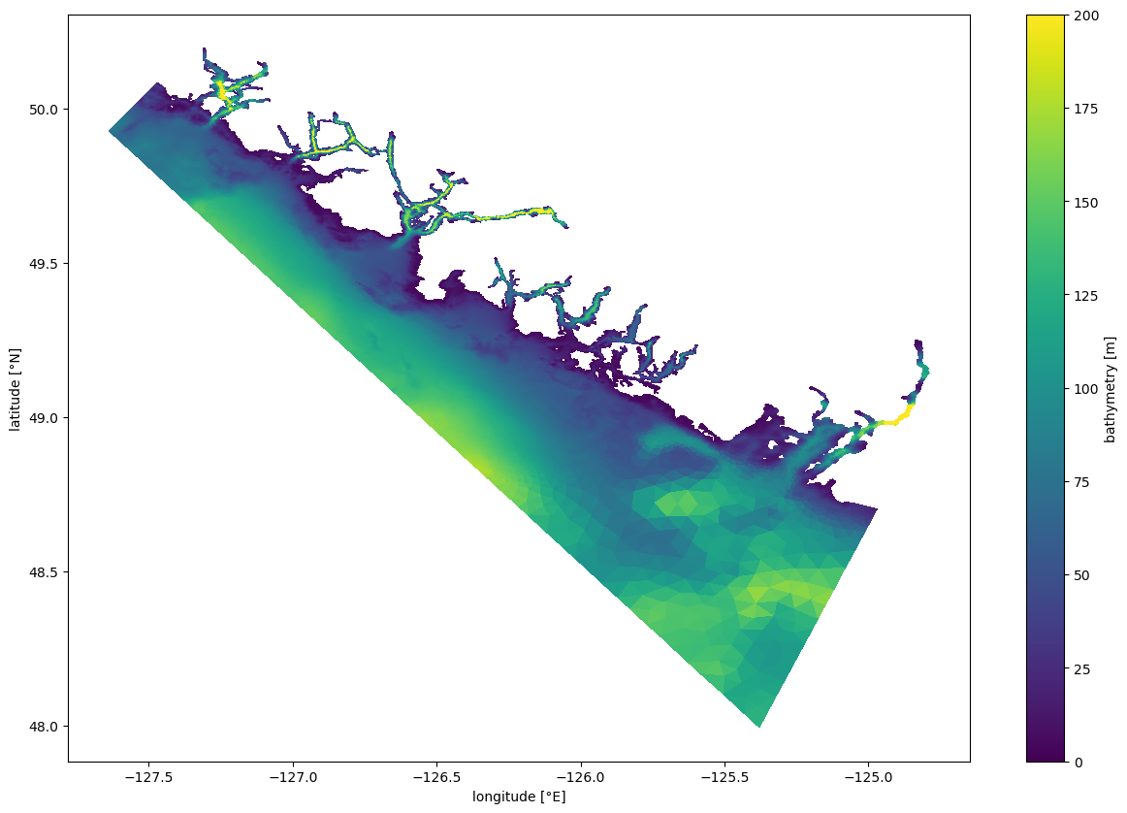
Figure 1: West coast Vancouver Island (WCVI) model domain. Colourscale shows the model bathymetry (in meters)

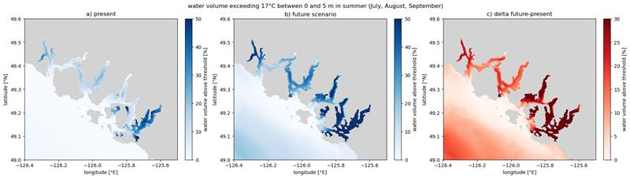
Figure 2: Maps of Clayoquot Sound showing the percentage of the top 5m of the water column exceeding 17°C in summer (July, August and September) in the (a) simulation for 2024 and (b) future scenario. Panel (c) shows the difference between both (future scenario minus 2024 simulation), highlighting the additional percentage of the surface waters that can exceed the temperature threshold in the future scenario.

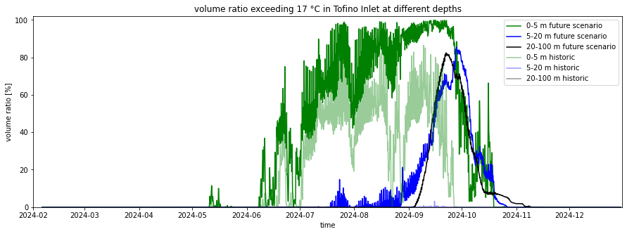
Figure 3: Time series of the percentage of water volume that exceeds 17°C in Tofino inlet at different depth ranges and different simulations. Bold colours indicate the future scenario, while paler colours indicate the 2024 simulation. Green colours indicate the volume in the surface depth range (0 to 5 m), blue colours represent upper waters below the surface (5 to 20 m) and black/grey represent deep waters (20 to 100 m). At surface, both simulations exceed the threshold between spring and autumn, while below 5 m the threshold is exceeded mostly in the future scenario.

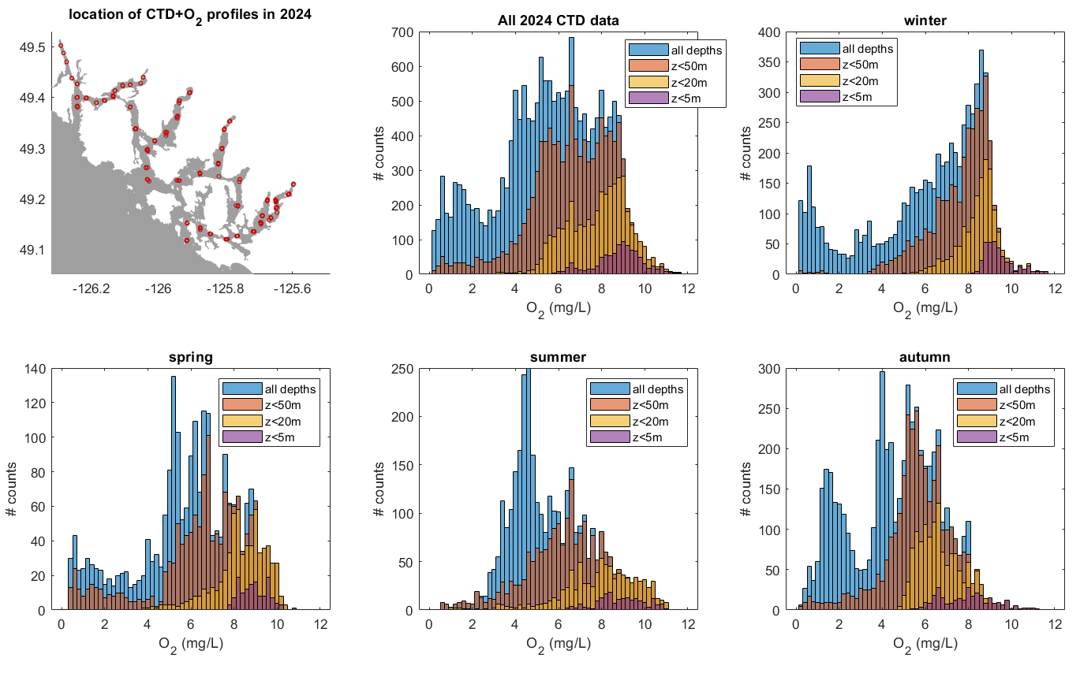
Figure 4: Location of the CTD profiles with oxygen data from 2024. The oxygen histograms show the distribution of oxygen data for the whole 2024 year and four seasons (winter: Jan-Mar, spring: Apr-Jun, summer: Jul-Sep, and winter: Oct-Dec). The different colours show the histograms for four different depth ranges: the whole water column (blue), top 50 meters (orange), top 20 meters (yellow) and top 5 meters (purple).

📈 References
Include full references for any publications referenced in other sections. Please format references in Harvard style according to Instructions to Authors for the Canadian Journal of Fisheries and Aquatic Sciences, at Canadian Science Publishing.
Rosen, S., Bianucci, L., Jackson, J.M., Hare, A., Greengrove, C., Monks, R., Bartlett, M. and Dick, J., 2022. Seasonal near-surface hypoxia in a temperate fjord in Clayoquot Sound, British Columbia. Frontiers in Marine Science, 9, p.1000041.

Foreman, M.G.G., Chandler, P.C., Bianucci, L., Wan, D., Krassovski, M.V., Thupaki, P., Cooper, G. and Lin, Y., 2024. A circulation model for inlets along the central West Coast of Vancouver Island. Atmosphere-Ocean, 62(1), pp.58-89.

